Journal of Nursing

About the Journal:
The Journal of Nursing is an international, peer-reviewed scholarly journal dedicated to advancing nursing science, clinical practice, nursing education, healthcare leadership, and evidence-based patient care. The journal serves as a global platform for nurses, clinicians, educators, researchers, and healthcare professionals to publish high-quality original research, systematic reviews, clinical studies, case reports, and innovative healthcare practices that contribute to improving patient outcomes and strengthening nursing practice across diverse healthcare settings.
The journal welcomes multidisciplinary research covering medical-surgical nursing, critical care, pediatric and neonatal nursing, mental health, oncology, community health, geriatric care, infection prevention, digital health, nursing informatics, healthcare quality improvement, and nursing leadership. By promoting scientific excellence and encouraging international collaboration, the journal aims to bridge the gap between research and clinical practice while supporting continuous professional development and innovation in modern nursing.

Latest News:
WHO Launches New Global Nursing and Midwifery Workforce Strategy (2026):-
The World Health Organization and international health partners have introduced updated strategies to strengthen the global nursing and midwifery workforce. The initiative emphasizes workforce retention, leadership development, expanded education, digital competencies, and equitable access to nursing care, aiming to address the projected shortage of healthcare professionals over the coming decade.
Telehealth and Community Nursing Improve Patient Care Outcomes:-
Healthcare systems are increasingly integrating telehealth, remote patient monitoring, and community-based nursing to improve access to healthcare services, particularly in rural and underserved regions. These digital care models enhance chronic disease management, rehabilitation, preventive care, and patient education while enabling nurses to deliver high-quality care beyond traditional hospital settings.
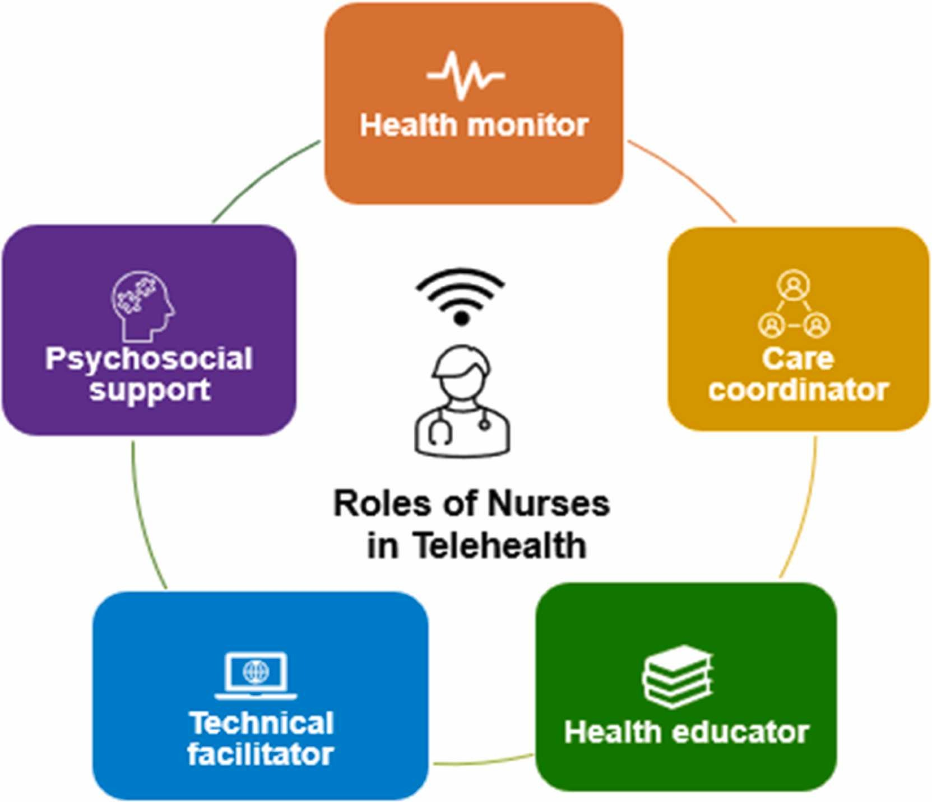

Nursing Education Advances Through Scholarships and Digital Learning:-
Healthcare organizations and academic institutions continue to invest in nursing education through scholarships, simulation-based learning, and advanced clinical training programs. Recent initiatives are helping nurses pursue higher education, strengthen evidence-based practice, and prepare for leadership roles in critical care, public health, and community nursing, ensuring a skilled future workforce.
AI Transforms Nursing Education and Clinical Decision-Making:-
Artificial intelligence is rapidly reshaping nursing education and clinical practice. Universities and hospitals are adopting AI-powered simulation training, virtual patients, electronic clinical decision support, and predictive analytics to improve nursing competencies, reduce medical errors, and enhance patient safety. As digital healthcare continues to expand, nursing informatics and AI literacy are becoming essential skills for the future nursing workforce.


Scientific Topics:

1. Nursing Education
Explores simulation-based learning, curriculum development, and competency-based education. The session highlights innovative teaching strategies, clinical training, and educational research that prepare the next generation of nursing professionals.
2. Nursing Management
Focuses on workforce planning, healthcare quality management, and organizational leadership. Covers effective management practices that enhance nursing performance, operational efficiency, and patient care.
3. Advanced Nursing Practice
Examines advanced clinical care, nurse practitioner roles, and specialized patient management. Highlights evidence-based interventions, autonomous practice, and multidisciplinary collaboration in modern healthcare.
4. Nursing Informatics & Technology
Explores electronic health records, telehealth, and clinical decision support systems. Focuses on technological innovations that improve healthcare delivery, patient safety, and nursing efficiency.
5. Evidence-Based Nursing Practice
Highlights clinical research integration, best practice guidelines, and patient outcome improvement. Encourages the application of scientific evidence to strengthen nursing practice and healthcare quality.
6. Trauma and Critical Care
Explores emergency nursing, intensive care, and trauma response strategies. Covers advances in critical care interventions, patient monitoring, and life-saving clinical practices.
7. Midwifery and Women Health Nursing
Focuses on maternal health, reproductive care, and prenatal and postnatal nursing. Highlights evidence-based practices that improve women's health throughout all stages of life.
8. Nursing Administration
Examines healthcare governance, nursing leadership, and quality improvement initiatives. Covers strategic planning, policy implementation, and effective administration of nursing services.
9. Improving Patient Education, Care & Outcomes
Explores patient education, care coordination, and outcome-focused interventions. Emphasizes patient-centered approaches that improve treatment adherence and overall healthcare experiences.
10. Public Health & Safety
Focuses on disease prevention, community health promotion, and public health preparedness. Highlights the essential role of nurses in protecting population health and ensuring community safety.
11. Pain Management & Preventive Medicine
Examines evidence-based pain management, preventive healthcare, and wellness promotion. Covers multidisciplinary approaches that improve patient comfort and long-term health outcomes.
12. Nursing Practice & Safety
Explores patient safety, infection prevention, and clinical risk management. Focuses on promoting safe, ethical, and high-quality nursing care across healthcare settings.
13. Nursing Leadership
Highlights leadership development, professional growth, and strategic decision-making in nursing. Encourages innovation, collaboration, and excellence in healthcare leadership.
14. Psychiatric and Mental Health Nursing
Focuses on mental health assessment, therapeutic interventions, and psychiatric care. Explores holistic nursing approaches that support recovery and improve psychological well-being.
15. Child and Adolescent Mental Health
Examines mental health promotion, behavioral disorders, and family-centered care for children and adolescents. Highlights early intervention strategies that support healthy emotional and psychological development.
16. Palliative Care
Explores symptom management, supportive care, and end-of-life nursing. Focuses on improving quality of life through compassionate, patient-centered, and multidisciplinary care.
17. Globalization and Health
Examines global health challenges, international healthcare collaboration, and health equity. Covers emerging diseases, cross-border healthcare initiatives, and strategies to strengthen global health systems.
18. Health Care Systems
Focuses on healthcare policy, service delivery models, and system-wide innovations. Highlights research that improves healthcare accessibility, quality, efficiency, and sustainability
Editorial in Chief:
Ashraf Youssef, Tarek Hammad
Takeda Development Center Americas, Inc., Cambridge, MA, USA
Biography:
Dr. Ashraf F. Youssef, M.D., Ph.D., M.B.A. DABT-2025 is a Global Pharmaceutical Safety Expert with > 30 years in drug development. His expertise covers both experimental and clinical safety. For the last 10 years he led post-marketed product safety at Shire/Takeda Pharmaceuticals, covering Neurology, Oncology, and Rare Diseases. Dr. Youssef has managed global teams and developed strategies for numerous high-profile drugs. A prolific speaker and author, he has presented at national and international conferences and published with significant contributions to drug safety standards.
6 Articles are attached herewith…

